Identifier | Variable | Scope | Lifetime
Module variables | AGENCY_NAME, fuel_level | global | However long the program is executed for
Parameter | pilot_name, mission_destination, duration | Local | Length of function call
Temporary/local variables | status, countdown | local | Length of function call
Methods | none
built-in function | print, range | global | forever

2. 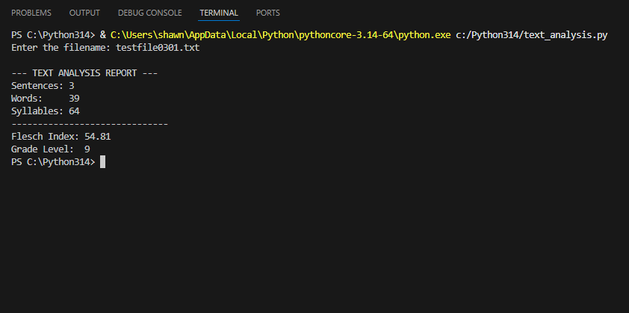

3.
